**SQL SERVER STORED PROCEDURES**

1. **Booking details of the customer**

USE [IMDB]

GO

/****** Object: StoredProcedure [dbo].[BookingDetails] Script Date: 07-12-2016 15:02:37 ******/

SET ANSI_NULLS ON

GO

SET QUOTED_IDENTIFIER ON

GO

ALTER Procedure [dbo].[BookingDetails]

@CustomerID int

AS

BEGIN

select Concat(c.FirstName,' ',c.LastName) as Name,b.Quantity as [Total Tickets],

m.Title as [Movie Title],th.Name as [Theatre Name],b.TotalDue as [Amount Paid]

from Bookings b

join Customer c

on b.CustomerID=c.CustomerID

join Ticket t

on t.TicketID=b.TicketID

join Showtime s

on s.ShowtimeID=t.ShowtimeID

join Movies m

on m.MovieID=s.MovieID

join Theatre th

on th.TheatreID=s.TheatreID

where c.CustomerID=@CustomerID;

END

Sample Input Data

exec BookingDetails @customerid=137

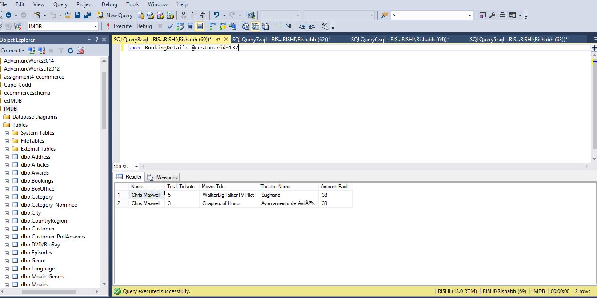

--------------------------------------------------------------------------

**2. Number of Episode for each season**

USE [IMDB]

GO

/****** Object: StoredProcedure [dbo].[EachSeasonNoEpisodes] Script Date: 07-12-2016 15:55:40 ******/

SET ANSI_NULLS ON

GO

SET QUOTED_IDENTIFIER ON

GO

ALTER Procedure [dbo].[EachSeasonNoEpisodes]

@TvShowID int

AS

BEGIN

select t.TvShowID,T.Title,S.SeasonName as [Season Name],

S.SeasonStartDate as [Season Start Date],S.SeasonEndDate as [Season End Date],

count(e.EpisodesID) as [Number of Episodes]

from TvShows T

Join Seasons S

ON t.TvShowID=s.TvShowID

Join Episodes E

ON e.SeasonID=s.SeasonID

where t.TvShowID=@TvShowID

group by t.TvShowID,T.Title,S.SeasonName,S.SeasonStartDate,S.SeasonEndDate

order by S.SeasonStartDate

END

Sample Input Data

exec EachSeasonNoEpisodes @Tvshowid=5082

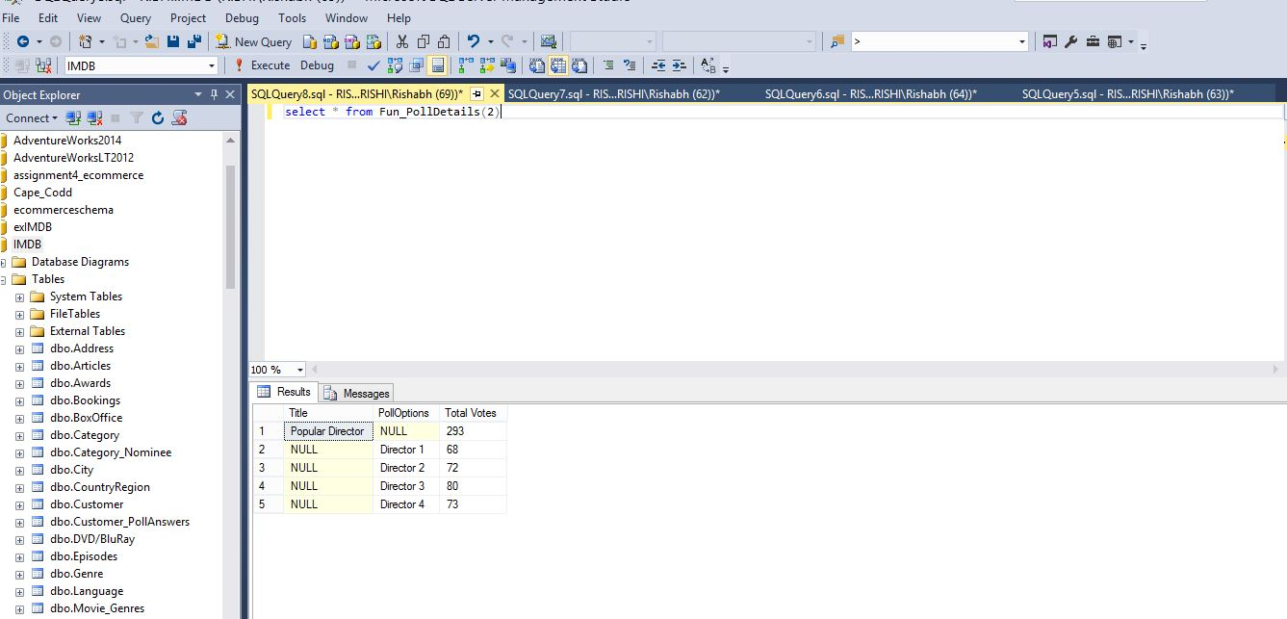

**--3 Displays the award winner for a given award year, title and category name**

Create procedure AwardWinner

@Year int,

@AwardName varchar(25),

@CName varchar(35)

AS

If @Cname in ('Best Actor','Best Actress')

begin

Select Person.FirstName,person.LastName,movies.Title as InMovie

from Awards

inner join category

on awards.AwardID=Category.AwardID

inner join Category_Nominee

on category.CategoryID=Category_Nominee.CategoryID

inner join Nomineee

on Category_Nominee.NomineeID=Nomineee.NomineeID

inner join person

on Nomineee.PersonID=person.PersonID

inner join movies

on Nomineee.MovieID=Movies.MovieID

where Awards.Title=@AwardName and Year(Awards.Year)=@Year AND

Category.[Category Name]=@CName and Nomineee.Winner=1

end

Else if @Cname in (' Best Motion Picture')

begin

Select movies.Title as Winner

from Awards

inner join category

on awards.AwardID=Category.AwardID

inner join Category_Nominee

on category.CategoryID=Category_Nominee.CategoryID

inner join Nomineee

on Category_Nominee.NomineeID=Nomineee.NomineeID

inner join movies

on Nomineee.MovieID=Movies.MovieID

where Awards.Title=@AwardName and Year(Awards.Year)=@Year AND

Category.[Category Name]=@CName and Nomineee.Winner=1

end

else

begin

Select TvShows.Title as Winner

from Awards

inner join category

on awards.AwardID=Category.AwardID

inner join Category_Nominee

on category.CategoryID=Category_Nominee.CategoryID

inner join Nomineee

on Category_Nominee.NomineeID=Nomineee.NomineeID

inner join TvShows

on Nomineee.TvShowID=TvShows.TvShowID

where Awards.Title=@AwardName and Year(Awards.Year)=@Year AND

Category.[Category Name]=@CName and Nomineee.Winner=1

end

Exec AwardWinner @year=2016,@awardname='Oscars',@cname='Best Actor';

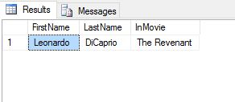

Exec AwardWinner @year=2016,@awardname='Oscars',@cname='Best Motion Picture';

